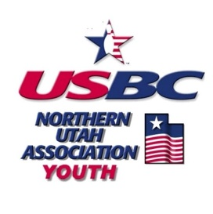
NUUSBCA
STAR OF TOMORROW
SCHOLARSHIP APPLICATION
The NUUSBCA Star of Tomorrow Scholarship is a $250.00 scholarship awarded yearly to a youth boy and girl bowler by a vote of the NUUSBCA Board of Directors. If there is neither a girl nor a boy applicant for the season applied, then the full amount goes to the most qualified applicant.

Eligibility Requirements:
- Be a current USBC youth card holder.
- Be a regular paying member of a certified NUUSBCA youth league who has bowled a minimum 33 games or 2/3 of league games for the current season.
- Must never have been suspended for any USBC rule violation.
- Must have competed in one NUUSBCA youth tournament in the current season.
- Must be 16 years of age as of August 1st of the current bowling season.
- Current GPA of 3.0 or higher (Attach verification to application)
- Application and essay must be postmarked no later than March 31st of the current season.

Name: | Telephone Number: | League Bowled:
Address | City, State | Zip
Parent/Guardian: | Date of Birth: | USBC ID Number:

I certify that all information provided in the application is correct to the best of my knowledge. I understand that knowingly providing false information will result in disqualification of my application.

Signature of Applicant: Date:

______________________________________________________ ___________________________________
Questionnaire (for help finding your stats please talk to your coach or log onto your account at bowl.com):
How many years have you been bowling?

List all the NUUSBCA tournaments you have bowled this season:

List all the non-NUUSBCA tournaments you have bowled this season (IE: Utah State, Pepsi, etc. 811:

List all the NUUSBCA tournaments you hold a title in:

Are you a current Junior Gold participant? _____________
What is your current average? _____________
What is your highest average? _____________
What is your highest game? _____________
What is your highest series? _____________

Essay:
Attach a 500-word essay or email a video entry 3-5 minutes long on how bowling has enhanced your life skills and how you plan to use those skills during college. Please email videos to NUUSBC@gmail.com with your name and USBCA member ID.

Entries must be postmarked by March 31st of the current season to be eligible. Please send completed application with essay to:
NUUSBCA Association Manager
Youth Scholarship
PO Box 734
Clearfield, UT 84089-0734

